**Brainstorm of Possible Action Steps**

**to Support Students in the Different Profiles**

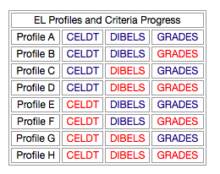

|  |  |
| --- | --- |
| **Profile** | **Possible Action Steps to Support Students** |
| **A** |  |
| **B** |  |
| **C** |  |
| **D** |  |
| **E** |  |
| **F** |  |
| **G** |  |
| **H** |  |